DATA ACQUISITION-D205

Western Governor University

Instructor: David Gagner

Date: 11/20/2022

Submitted By:

Nikki Shrestha

1. **Research Question**

Find all the female customers who use Fiber Optic internet service.

**A1. Identifying Data**

The research question requires the analysis of customer dataset from the original data set and the services table from the add-on CSV data set. The customer table has all the information of the customer like customer id, gender etc. The service table has different types of internet services that the customer used. To answer the research question, I use customer id and gender column from the customer table and internet service column from the services table.

1. **Logical Data Model**

|  |  |
| --- | --- |
| **Table** | **Field** |
| customer | customer_id |
| Customer | gender |
| Services | Customer_id |
| Services | internetservice |

**B1. Code for Physical data mode**

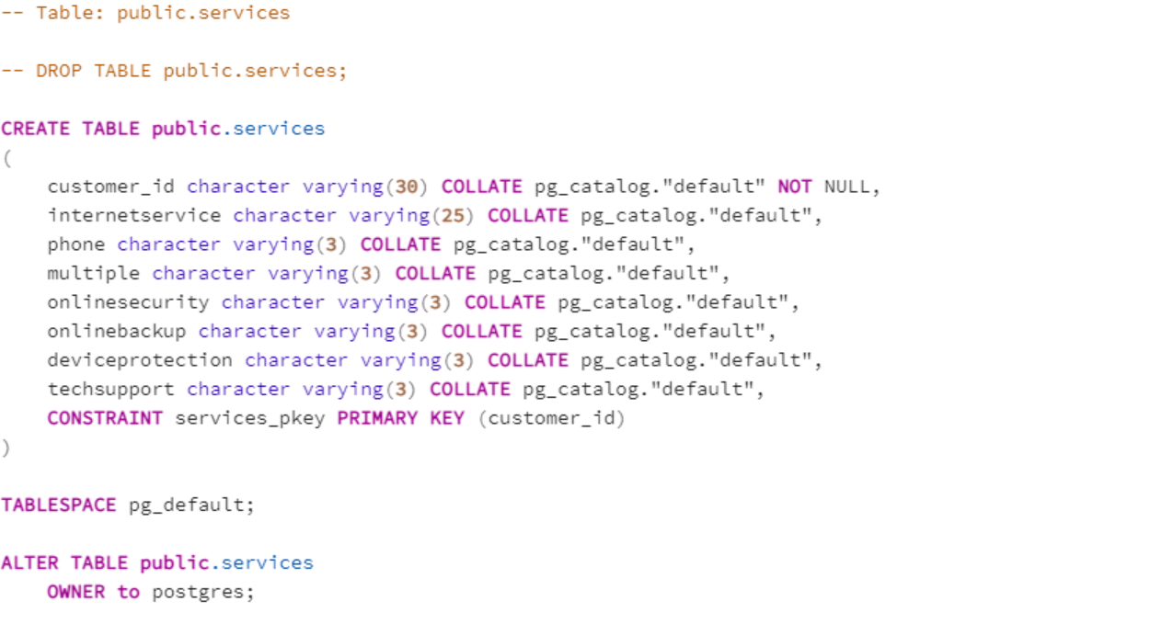

**B2. Loading CSV data**

COPY services

FROM ‘c:\users\labuser\desktop\services.csv’

DELIMITER ‘,’

CSV HEADER;

1. **Write SQL statement(s) for a query or queries that inform the research question summarized in part A.**

1. **Determine how often the add-on file should be acquired and refreshed in the database for the data to remain relevant to the business and the research question.**

The add-on file should be acquired and refreshed in the database monthly to see the recent Fiber optic internet service used by the female customers.

E.  **Create an SQL script that performs the process of loading the add-on data.**

COPY services

FROM ‘c:\users\labuser\desktop\services.csv’

DELIMITER ‘,’

CSV HEADER;

**F.  Provide a Panopto video recording that includes a demonstration of the functionality of the code used for the analysis and a summary of the programming environment.**

<https://wgu.hosted.panopto.com/Panopto/Pages/Viewer.aspx?id=69cd06b5-61bb-401d-8fea-af57011cada2>

**G.  Record the web sources used to acquire data or segments of third-party code to support the application. Be sure the web sources are reliable.**

* I didn’t use an online source in section G.

**H.  Acknowledge sources, using in-text citations and references, for content that is quoted, paraphrased, or summarized**.

Import CSV File Into PostgreSQL Table. (n.d.). *PostgreSQL Tutorial Website.* Retrieve from

* [https://www.postgresqltutorial.com/import-csv-file-into-posgresql-table/](https://protect-us.mimecast.com/s/6w0uCR6KEoUGlmB0lH9TJoP?domain=postgresqltutorial.com/)